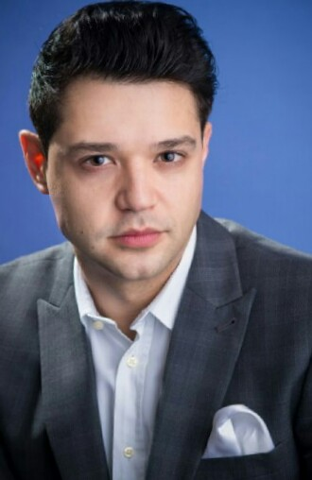
I am an Associate Professor in Developmental Psychopathology, Director of the MSc in Applied Developmental Psychology, and the Director of the InteRRaCt Lab at Queen’s University Belfast. I have served previously as an Assistant Professor and an Associate Professor at London Metropolitan University, London, UK and at Tomsk State University, Russia, respectively. I am an Associate Editor for the Journal Personality and Individual Differences and the Journal Acta Psychologica (Indvidual Differences Section); and a member of the Editorial Board in Frontiers in Applied Mathematics and Statistics, and Frontiers in Psychology. I participate actively in dissemination of scientific findings in both academic audiences and the public with my research on narcissism to be the subject of frequent media coverage from the world’s largest international broadcasters (e.g., BBC World Service, CNN, Times and Forbes) resulting so far in more than 1,000 pieces of coverage worldwide. In January 2022, I was invited to become a Member and an Advocate of the European Association for Personality Psychology (EAPP) for the UK and Ireland.
In 2011, I was awarded a European Marie Curie Fellowship to pursue a PhD (2011-2015) at the Centre for Brain and Cognitive Development at Birkbeck University of London. My doctoral thesis “Individual Differences in Infant Visual Attention: Links to Child Temperament, Behaviour and Genetic Variation” explored the genetics of visual attention in the first year of life; and the degree to which individual differences in newborns’ and infants’ visual attention predict variation in temperament, cognition and symptoms of psychopathology in childhood. I conducted my MSc thesis in the InLab, under the supervision of Professor Yulia Kovas, exploring social (e.g. stereotype threat) and biological (e.g. prenatal testosterone) factors that contribute to sex differences in spatial and mathematical ability across development. In 2011, I received an MSc degree in Cognitive and Clinical Neuroscience from Goldsmiths University of London, and a BSc degree in Psychology from Panteion University of Social and Political Sciences in 2009.
My current research interests involve exploring the degree to which dark personalities (with a particular focus on narcissism) contribute to resilience and performance across contexts. My work has focused on narcissism, as a first step, in order to highlight some positive sides of this seemingly dark trait, such as showing resilience. The objective of my research programme is not to rehabilitate dark personalities, but rather to contextualize them in a complex web of societal costs and benefits. In so doing, I plan, through collaborative work, to be able to look into ways in which society can harness the energy of dark personalities while also curtailing their potential for harm.

